

SOP: Workflow Optimization with HubDB Lookup
This SOP documents how we replaced per-coach workflow branches with a single HubDB lookup, using the Accountability Coach workflow as the reference build. Items marked [TO CONFIRM] are inferred from screenshots or not yet verified.

1. Purpose
This workflow copies a company's Accountability Coach, and that coach's name, email and meeting link, onto the company's associated contacts and payment, using one HubDB lookup instead of a branch per coach.
As the company grew, we added more coaches. Our automations used a separate branch per coach, each with the same steps inside. Past 10 coaches this became hard to maintain: every new coach meant a new branch, and every change meant editing each branch.
Each coach's details live in a HubDB table. A Node.js custom code action looks up the right row and outputs those details. The rest of the workflow uses the outputs instead of hard-coded values.
Results so far:
- The reference workflow dropped from 51 blocks to 6.
- Adding or changing a coach is a HubDB row edit, not a workflow rebuild.
- We can merge workflows we couldn't combine before, either because they hit the block limit or because one big workflow would have been too hard to maintain.
 | Old workflow | New workflow (2026)
Workflow | Copy AC from Company to Associated Contacts (flow ID 1868330022) | Copy AC from Company to Associated Contacts 2026 (flow ID 1905477215)
Coach logic | Branch on Assigned Accountability Coach: 10 coach branches + None met | One custom code action reads HubDB
Actions | 51 (5 edit-record actions x 10 branches + branch) | 6 (1 custom code + 5 edit records)
Coach data source | Typed into each action | HubDB table Accountability Coach Details
Add a coach | Add a branch with 5 actions | Add a HubDB row

When to use this pattern
Use it when a workflow has many branches that run the same steps and differ only in the values they set.
Situation | Fit | Why
Many branches, identical steps, different values (e.g. per coach, per region, per product) | Strong | Values move to HubDB; steps collapse to one set
Workflow near the block limit, or two workflows we want to merge | Strong | Fewer blocks per branch frees room
Branches that also differ in steps (different emails, delays, tasks) | Partial | Lookup can select values, but differing steps still need branches; a lookup output could drive a smaller branch

2. Trigger
A company enrolls whenever its Assigned Accountability Coach changes, and can re-enroll on every later change.
Setting | Value
Workflow type | Company-based
Enrollment criteria | Assigned Accountability Coach has been updated in the last 0 days
Re-enrollment | On
Manual enrollment | Available (Enroll button) for testing or back-filling
Status | ON
The old workflow uses the same trigger. Only one of the two should be ON at a time, or both will update the same records [TO CONFIRM cutover date and when the old workflow is turned off].

3. Step-by-step logic
One custom code action looks up the coach in HubDB, then five edit-record actions write the results.
Step | Action | Record type | Association | Property to edit | Change type | Value
1 | Custom code | n/a | n/a | n/a | n/a | Outputs hubdb_ac_name_output, hubdb_email_output, hubdb_meeting_link_output
2 | Edit record | Contact (Associated object) | All associated contacts | Assigned Accountability Coach | Replace | Assigned Accountability Coach (enrolled company)
3 | Edit record | Payment (Associated object) | The associated payment | Assigned Accountability Coach | Replace | Assigned Accountability Coach (enrolled company)
4 | Edit record | Contact (Associated object) | All associated contacts | [Accountability Call] Meeting link | Replace | hubdb_meeting_link_output
5 | Edit record | Contact (Associated object) | All associated contacts | Assigned AC (Name) | Replace | hubdb_ac_name_output
6 | Edit record | Contact (Associated object) | All associated contacts | Assigned AC (Email) | Replace | hubdb_email_output
Notes:
- Steps 2 and 3 copy the coach straight from the company. They do not depend on HubDB.
- Step 3 targets "The associated payment" (single), while contact steps target all associated contacts.

Step 1: custom code logic
- Read the token from the secret and the coach value from ac_name, trimmed.
- If the value is empty or the text "undefined", return empty outputs and stop.
- Fetch the rows of the table's draft version (GET /cms/v3/hubdb/tables/414360419/rows/draft) and find the row whose hubdb_hubspot_id, as text, equals the coach value.
- If a row is found, map its columns to the three outputs (e.g. hubdb_meeting_link_output = coachData.hubdb_ac_meeting_link).
- If no row is found, return empty outputs.
- On an API error, log "API Error:" with the message and rethrow, so the action fails.
Behaviour to know:
- The code reads the draft table, so a saved edit applies to the next enrollment even if it is not published. This also means a half-finished edit goes live immediately.
- Matching happens in the code after fetching rows; the API call has no filter. Only the first page of results is read. That is fine at 9 rows, but check the default page size before the table grows large [TO CONFIRM page size; I believe it is well above our row count but have not verified it].
- Output values are not trimmed, so a space typed into a HubDB cell is copied onto contacts.
- If a matched row has an empty column, that output comes back undefined [TO CONFIRM how the edit-record step handles it].
Setting | Value
Language | Node.js 20.x
Client | HubSpot Client v11 (selector shown; code uses axios)
Full code:
const axios = require('axios');
exports.main = async (event, callback) => {
const token = process.env.HubDB_Lookup;
const coachId = String(event.inputFields['ac_name'] || '').trim();
if (!coachId || coachId === 'undefined') {
callback({ outputFields: {} });
return;
}
try {
const response = await axios.get(`https://api.hubapi.com/cms/v3/hubdb/tables/414360419/rows/draft`, {
headers: { 'Authorization': `Bearer ${token}` }
});
const matchedRow = (response.data.results || []).find(row =>
String(row.values.hubdb_hubspot_id) === coachId
);
if (matchedRow) {
const coachData = matchedRow.values;
callback({
outputFields: {
hubdb_ac_name_output: coachData.hubdb_ac_name,
hubdb_email_output: coachData.hubdb_ac_email,
hubdb_meeting_link_output: coachData.hubdb_ac_meeting_link
}
});
} else {
callback({ outputFields: {} });
}
} catch (error) {
console.error("API Error:", error.message);
throw error;
}
}

4. Inputs
The workflow needs three inputs: the company's coach value, an API secret, and the published HubDB table.
Input | Source | Used by | Notes
Assigned Accountability Coach | Enrolled company property | Step 1 (as ac_name), steps 2 and 3 | Holds the coach's User HubSpot ID [TO CONFIRM property type]
HubDB_Lookup | Workflow secret, read as process.env.HubDB_Lookup | Step 1 | [TO CONFIRM: private app token, scopes, owner]
Accountability Coach Details | HubDB table, ID 414360419, portal 48857757 | Step 1 | One row per active coach; the code reads the draft version, so saved edits apply without publishing

HubDB table: Accountability Coach Details
Location: Content > HubDB > Accountability Coach Details
Column (as shown in UI) | Internal name | Holds | Example
HubDB Hubspot ID | hubdb_hubspot_id | User hubspot ID | 77941157
HubDB AC Name | hubdb_ac_name | Coach display name | Ram Porter
HubDB AC Email | hubdb_ac_email | Coach email | ram@theprofessionalbuilder.com
HubDB AC Meeting Link | hubdb_ac_meeting_link | Accountability call booking link | .../meetings/coach-ram-p/accountability-call

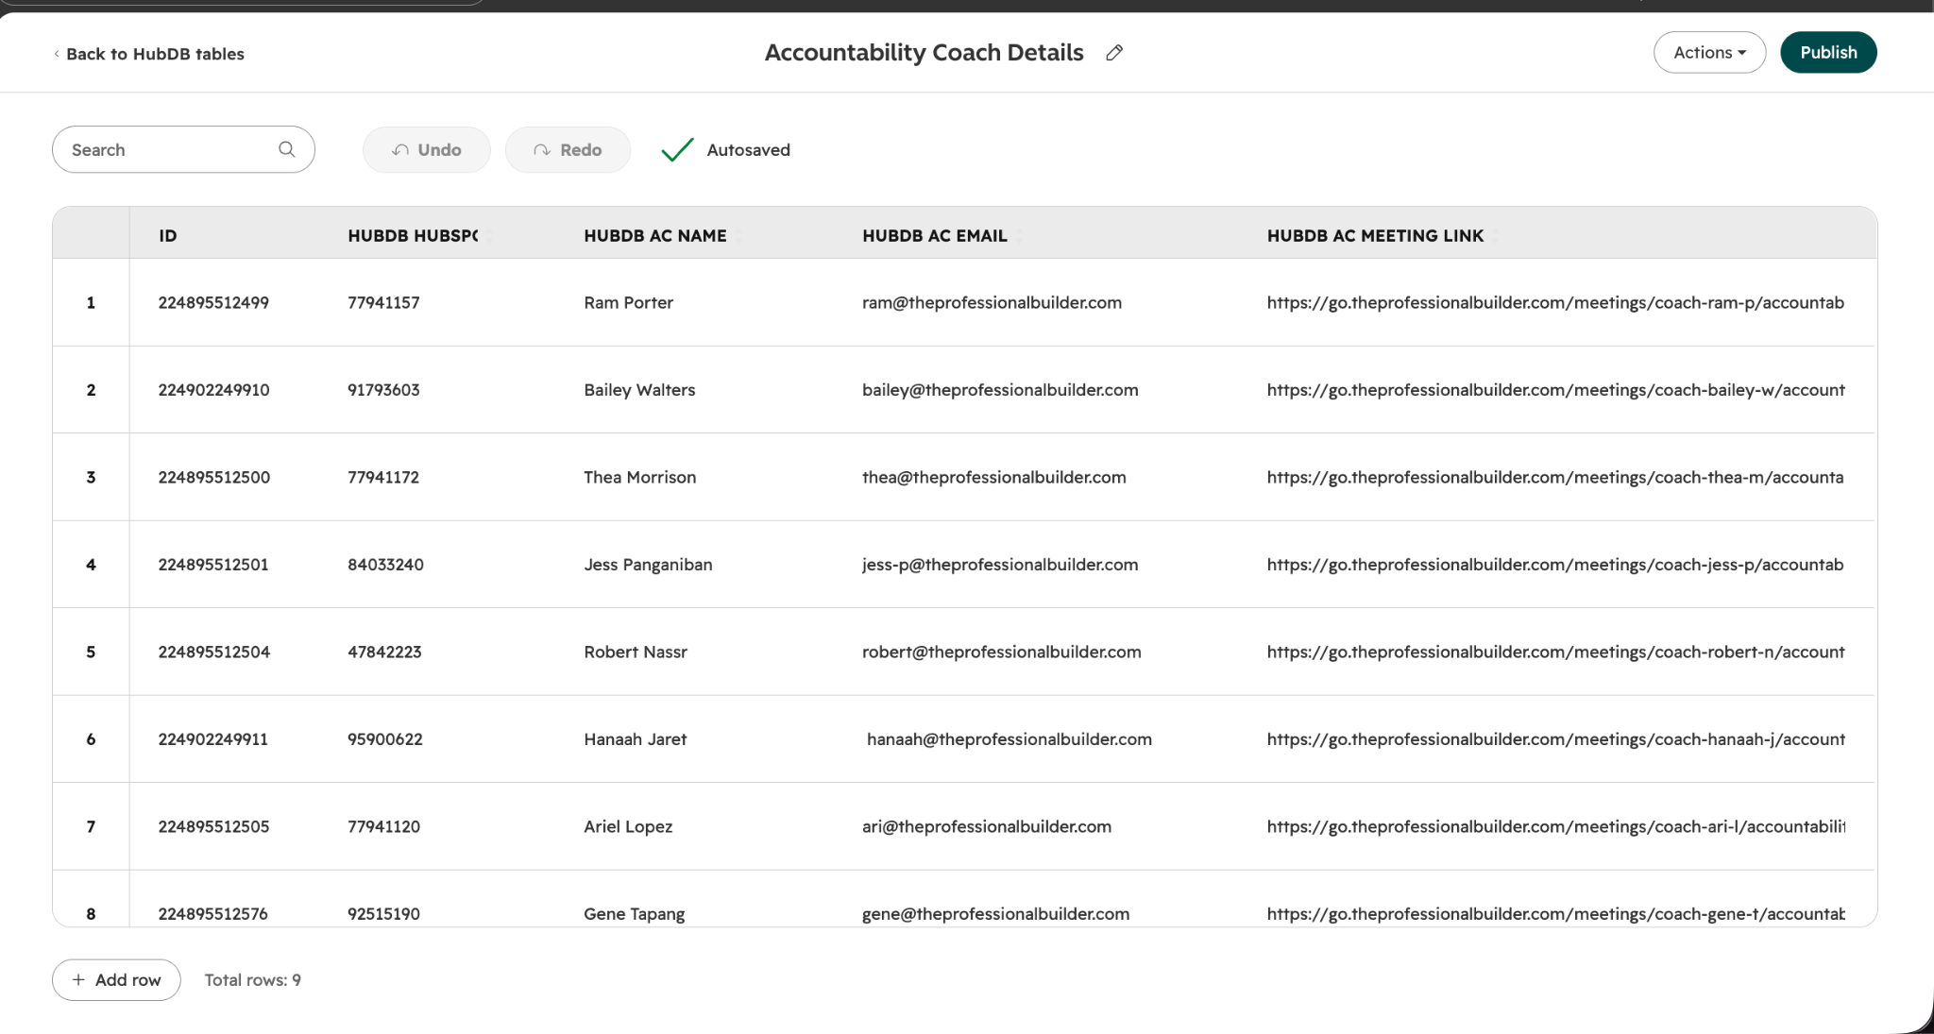

5. Outputs
The code returns three strings, and the workflow writes five property values to associated records.
Custom code outputs (step 1)
Output | Type | Source column
hubdb_ac_name_output | String | hubdb_ac_name
hubdb_email_output | String | hubdb_ac_email
hubdb_meeting_link_output | String | hubdb_ac_meeting_link
All three are empty when the coach value is blank or has no matching row.
Properties updated
Record | Property | Set by | Value
All associated contacts | Assigned Accountability Coach | Step 2 | Company's coach
The associated payment | Assigned Accountability Coach | Step 3 | Company's coach
All associated contacts | [Accountability Call] Meeting link | Step 4 | hubdb_meeting_link_output
All associated contacts | Assigned AC (Name) | Step 5 | hubdb_ac_name_output
All associated contacts | Assigned AC (Email) | Step 6 | hubdb_email_output

